OESOPHAGEAL OBSTRUCTION PATHWAY
= yes = no

TOP TIPS
- Oesophageal obstruction is an emergency. Lack of action can cause perforation. Discuss with gastroenterology early
- DO NOT use fizzy drinks or medications to try and disimpact oesophageal obstructions.
- Most cases have underlying oesophageal disease.
- Chicken and fish bones are RARELY seen on x-ray.
- Some obstructions above the sternal notch are managed by ENT/ORL +/- Gastroenterology
Is the history consistent with oesophageal obstruction?
i.e. Recent ingestion of food or foreign body with subjective sensation of object retained in oesophagus
☐ Yes Continue |  | ☐ No Stop pathway  Give appropriate clinical care
Ensure baseline management and investigations:
☐ Nil by mouth
☐ IV Analgesia — Paracetamol 1g IV qds + Morphine 1mg IV to be titrated
☐ IV Fluids — 0.9% Saline give replacement and resuscitation requirements
☐ Bloods — FBC, U+E, LFT, coagulation screen & G+H
Diabetic patients: ☐ GIK in place of IV saline for replacement fluids (see local protocols)
Does the patient have any signs of high grade obstruction or airway compromise?
☐ Stridor
☐ Hypersalivation
☐ Inability to swallow own saliva
☐ No |  | ☐ Yes
Senior decision needed for removal. Contact:
☐ Anaesthetist for airway support
☐ Gastroenterology Registrar (In hours) (if available otherwise general medical registrar) or Consultant (out of hours) for OGD
Does the patient have any signs of oesophageal perforation?
☐ Fever
☐ Subcutaneous crepitus e.g. neck, upper thorax
☐ Swelling of neck may be focal or general
☐ Tachycardia > 100 BPM
☐ No |  | ☐ Yes
This patient needs urgent imaging and surgical assessment:
☐ CT Contrast Neck and Chest
☐ Contact Surgical registrar for urgent assessment
☐ Contact Gastroenterology registrar (In hours) or Consultant (Out of hours) for possible urgent OGD
☐ Contact Anaesthetist for airway support
Identify:
☐ Time of impaction______:_____
☐ Type of food / object Ingested
☐ Site of impaction—Above or below sternal
☐ Previous impaction, oesophageal disease or psychiatric disorder?

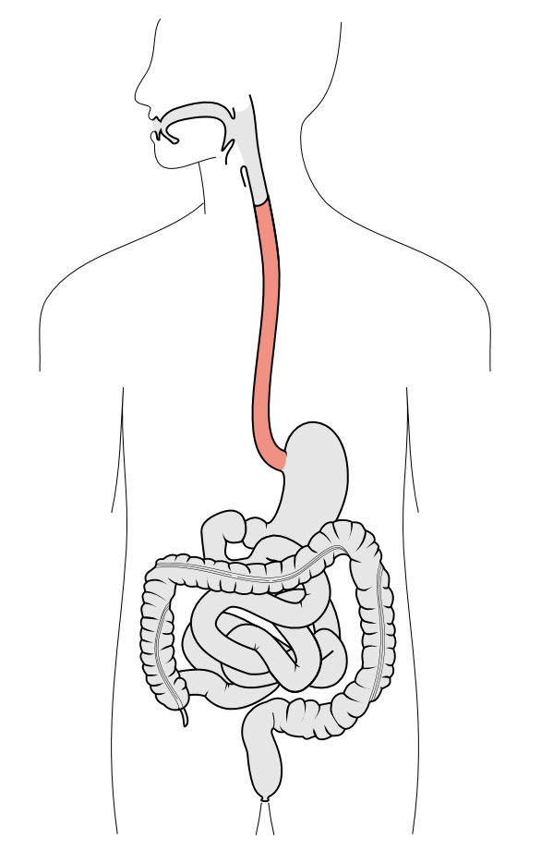 | SOFT FOOD BOLUS | SHARP OBJECT BELOW STERNAL NOTCH OR BLUNT OBJECT AT ANY LOCATION | SHARP OBJECT ABOVE STERNAL NOTCH
 | ☐ No CXR or Neck X-Ray  ☐ Discuss with gastroenterology (if available otherwise general medical team) before referral to medicine  ☐ Time D/W Gastroenterology ___:___  ☐ send referral for OGD  ☐ IF NO SIGNS OF HIGH GRADE OBSTRUCTION AIM IS TO REMOVE SOFT FOOD BOLUS WITHIN 24 HOURS OF IMPACTION  ☐ These patients are likely same day discharges. | ☐ CXR + Lateral Neck X-Ray Confirm location, size and number  ☐ Discuss with gastroenterology (if available otherwise general medical team) before referral to medicine  ☐ Confirm if anaesthetic support required for OGD and if to be performed in theatre or gastro suite.  ☐ Time D/W Gastroenterology _:_  ☐ send referral for OGD  ☐ AIM IS TO REMOVE SHARP OBJECTS, MAGNETS AND BATTERIES WITHIN 6 HOURS OF IMPACTION | ☐ CXR + Lateral Neck X-Ray Confirm location, size and number  ☐ Discuss with local ORL/ENT + Gastroenterology at your providing centre 24/7  ☐ Discuss with anaesthetics may need airway support for transfer
 |  |  | LOCATION OF OGD:
☐ Most procedures done in Gastro Department
☐ High risk cases done in theatre, decision made by gastroenterology consultant
Arrange:
☐ Acute theatre booking
☐ Referral form for OGD
☐ Inform theatre and anaesthetic coordinators
POST OGD Discharge Planning
☐ Commence PPI in most cases
☐ Post procedure and discharge instructions as per OGD report
Most cases require elective repeat OGD after period of PPI to exclude underlying pre-disposing pathology.

